Simulating Car Sales.
Excel Spreadsheet
 |  | Car Sales Simulation
 | A | B | C | D | E | F | G
4 |  | Sales | P(X=x) | P(X<x) | X
5 |  | 0 | 0.1 | 0 | 0
6 |  | 1 | 0.2 | 0.1 | 1
7 |  | 2 | 0.4 | 0.3 | 2
8 |  | 3 | 0.2 | 0.7 | 3
9 |  | 4 | 0.1 | 0.9 | 4
10
11
12 | Date | Rand() | X | Average | Variance | If X=1 | Est P(X=1)
13 | 01-Jan | 0.933776 | 4 | 4 | #DIV/0! | 0 | 0
 | 02-Jan | 0.825442 | 3 | 3.5 | 0.5 | 0 | 0
 | 03-Jan | 0.880881 | 3 | 3.333333 | 0.333333 | 0 | 0
 | 04-Jan | 0.342366 | 2 | 3 | 0.666667 | 0 | 0
 | 05-Jan | 0.588556 | 2 | 2.8 | 0.7 | 0 | 0

Formulae

A13 = date
B13 = RAND()
C13==VLOOKUP(B19,$D$5:$E$9,2) just handy for random values
D13=AVERAGE($C$13:C13) cumulative average of sales 1..n
E13= STDEV($C$13:C13)^2
F13=IF(D13=1,1,0)
G13=AVERAGE($F$13:F13) estimate of P(X=1) based on 1..n

Copy row 13 for 364 rows to get a full year.

VLOOKUP(x,table,k) scans column 1 of the table for row with largest 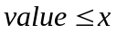, it returns the value from the kth column in that row of the table.

So if RAND() <0.1 , the value from row 5 (row 1 in table) and Column E (column 2 of table) is Returned

P(RAND()<0.1)=0.1 so P(X=0)=0.1

If 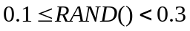 then value in E6 is returned X=1

P() =0.3 –0.1 =0.2 as required

and so on.

Charts

Cumulative averages over the year. E(X)=2

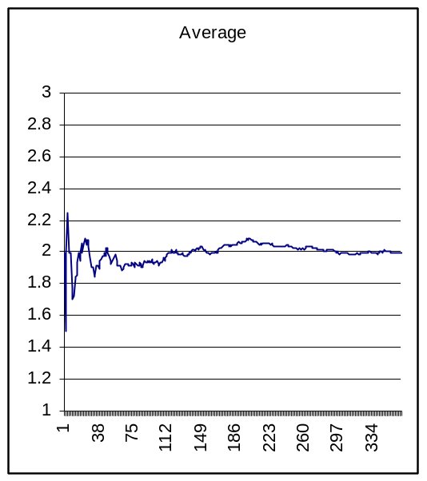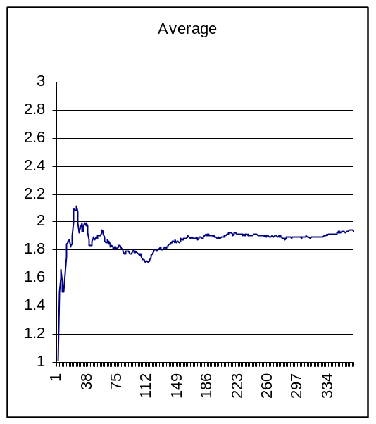

Plotted value 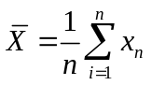 n=1,2..365

Estimates of P(X=1)=0.2 P(X=2)=0.4

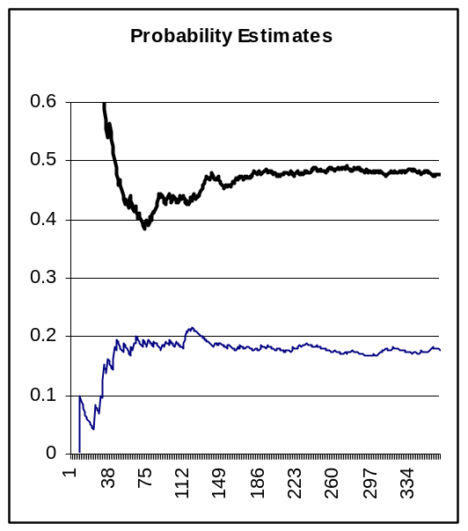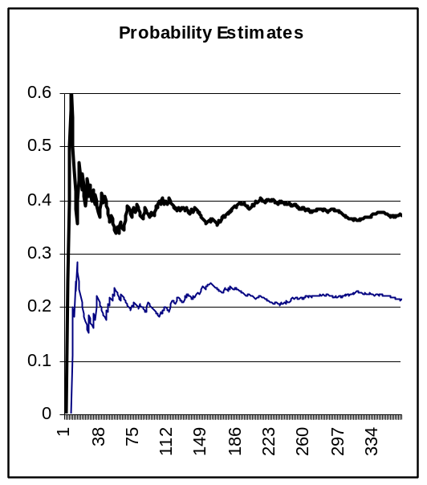

Estimates of mean settle down more quickly. From a small sample we might get a reasonable idea of what the mean is. We need larger samples to estimate probabilities.

